**MINOR PROJECT SYNOPSIS**

**MECHANICAL ENGINEERING BATCH 2021-2025**

**DATED – 23rd August, 2024**

**Title:**  
**Advanced Non-Pneumatic Tire Design with Optimized Honeycomb Structure for Military Applications**

**1. Introduction:**

The design and development of **non-pneumatic tires (NPTs)**, utilizing an **optimized honeycomb structure** for improved **durability**, **shock absorption**, and **load-handling capabilities**, is the focus of this project. These tires are intended for **military vehicles** operating in extreme conditions. The project will explore the use of **advanced materials** and innovative design features, such as **variable stiffness honeycomb structures** and **integrated smart technologies**, to enhance performance and meet the rigorous demands of military applications.

**2. Literature Survey:**

Recent advancements in **NPT technology** emphasize the importance of **structural integrity** and **material selection** to withstand high loads and provide effective shock absorption. Studies on **honeycomb structures** have demonstrated their potential in offering **lightweight yet robust solutions** for various applications. The use of **polyurethane spokes**, **metallic foams**, and **carbon fiber-reinforced composites** in NPTs has shown promising results in improving the overall performance of tires in terms of **durability** and **shock resistance**.

**3. Objectives:**

* **Design and analyse** a non-pneumatic tire with a **multi-layered honeycomb structure** tailored for military vehicles.
* **Select and test materials** that offer a balance between **strength, flexibility,** and **thermal stability** under extreme conditions.
* **Incorporate advanced features** like **modular design**, **embedded sensors** for real-time monitoring, and **camouflage capabilities** to enhance military applications.
* **Validate the tire's performance** through **simulation** and **physical testing** under military-relevant scenarios.

**4. Proposed Design:**

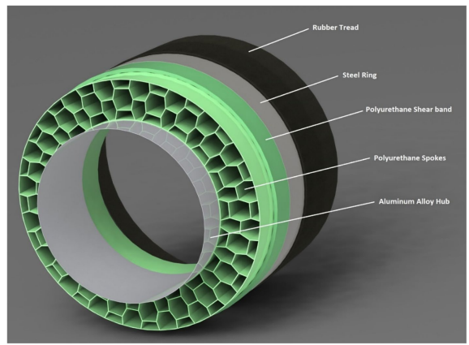**4.1. Design Approach:**  
The tire will feature a **multi-layered honeycomb structure** with **variable stiffness** to optimize load distribution and shock absorption. The outer layer will be made of **carbon fiber-reinforced composite**, while the inner layers will use **metallic foams** and **polyurethane spokes** to balance strength and flexibility.

**4.2. Material Selection:**  
Materials will be chosen based on their ability to withstand **extreme environmental conditions** while maintaining **lightweight properties**. The selected materials include **self-healing polymers** for the outer layer, **metallic foams** for the middle layer, and **polyurethane** for the innermost layer.

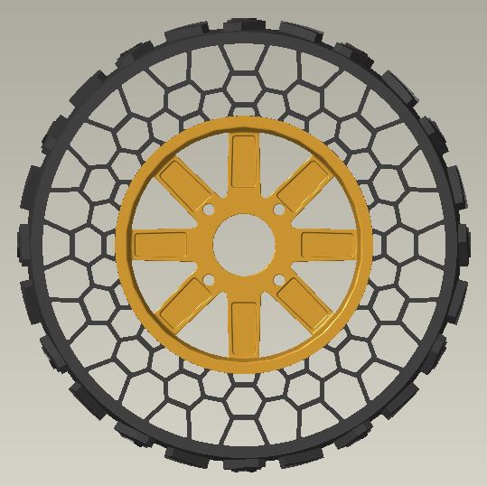

**4.3. Simulation and Testing:**  
The design will undergo **Finite Element Analysis (FEA)** to simulate performance under various load conditions, followed by **physical testing** to validate the results. The tests will focus on **shock absorption**, **load distribution**, and **durability** in military-relevant environments.

**5. Objectives:**

* **Real-Time Monitoring:** Integrate **embedded sensors** for real-time monitoring of tire performance, including **temperature**, **stress**, and **wear**.
* **Modular Design:** Develop a **modular tire design** that allows for quick adaptation to different terrains and missions.
* **Camouflage Capabilities:** Explore materials and surface treatments that enable the tire to blend into various environments, enhancing **stealth operations**.

**6. Expected Outcomes:**

* **Innovative Tire Design:** A **non-pneumatic tire** optimized for **military vehicles**, offering superior **shock absorption**, **durability**, and **adaptability** to different terrains.
* **Military Application:** A comprehensive analysis demonstrating the tire's **feasibility** for military use, with potential applications in **stealth operations** and **extreme environments**.
* **Enhanced Durability:** A tire that can withstand **extreme conditions** without compromising performance, reducing the need for frequent maintenance and replacement.

**7. Conclusion:**

The proposed non-pneumatic tire design aims to meet the specific needs of military vehicles, providing a **robust, durable, and adaptable solution** for challenging terrains and missions. The project will result in a tire that not only withstands the rigors of military use but also enhances the vehicle's overall performance.

**8. References:**

* **Design and Performance Analysis of Vehicle Tyre Pattern Material Using Finite Element Analysis and ANSYS** <https://doi.org/10.4028/www.scientific.net/kem.777.426>.
* **Design and Structural Analysis of Non-Pneumatic Tyres for Different Structures of Polyurethane Spokes**. <https://doi.org/10.1186/s44147-022-00093-5>

**Student Names and Roll Numbers:**

* **Maanik Jain** UEM219081
* **Sahil Rangra** UEM219087
* **Sangam Sharma** UEM219088